**Purpose**

App Service Web Apps is a platform that is optimized for hosting websites and web applications. This platform-as-a-service (PaaS) offering lets you focus on your business logic while Azure takes care of the infrastructure to run and scale your apps.

**Scenario**

This quick start shows how to deploy your ASP.NET app to Azure Web Apps. When you’re finished, you’ll have a publicly accessible web application hosted in the cloud.

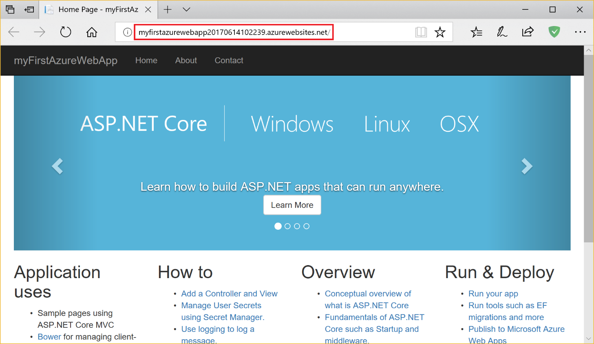

## Prerequisites

To complete this tutorial, you will need [**Visual Studio 2017**](https://www.visualstudio.com/downloads/) installed with the **ASP.NET and web development** workload.

## Create

In Visual Studio:

* Create a project by selecting **File > New > Project**.
* Select **Visual C# > Web > ASP.NET Core Web Application**.  
  Hint: If you do not see the ASP.NET Core Web Application project type, learn how to [*modify your Visual Studio installation*](https://docs.microsoft.com/en-us/visualstudio/install/modify-visual-studio) to include the ***Web Development*** workload.
* Name the application myFirstAzureWebApp
* Click **OK**.

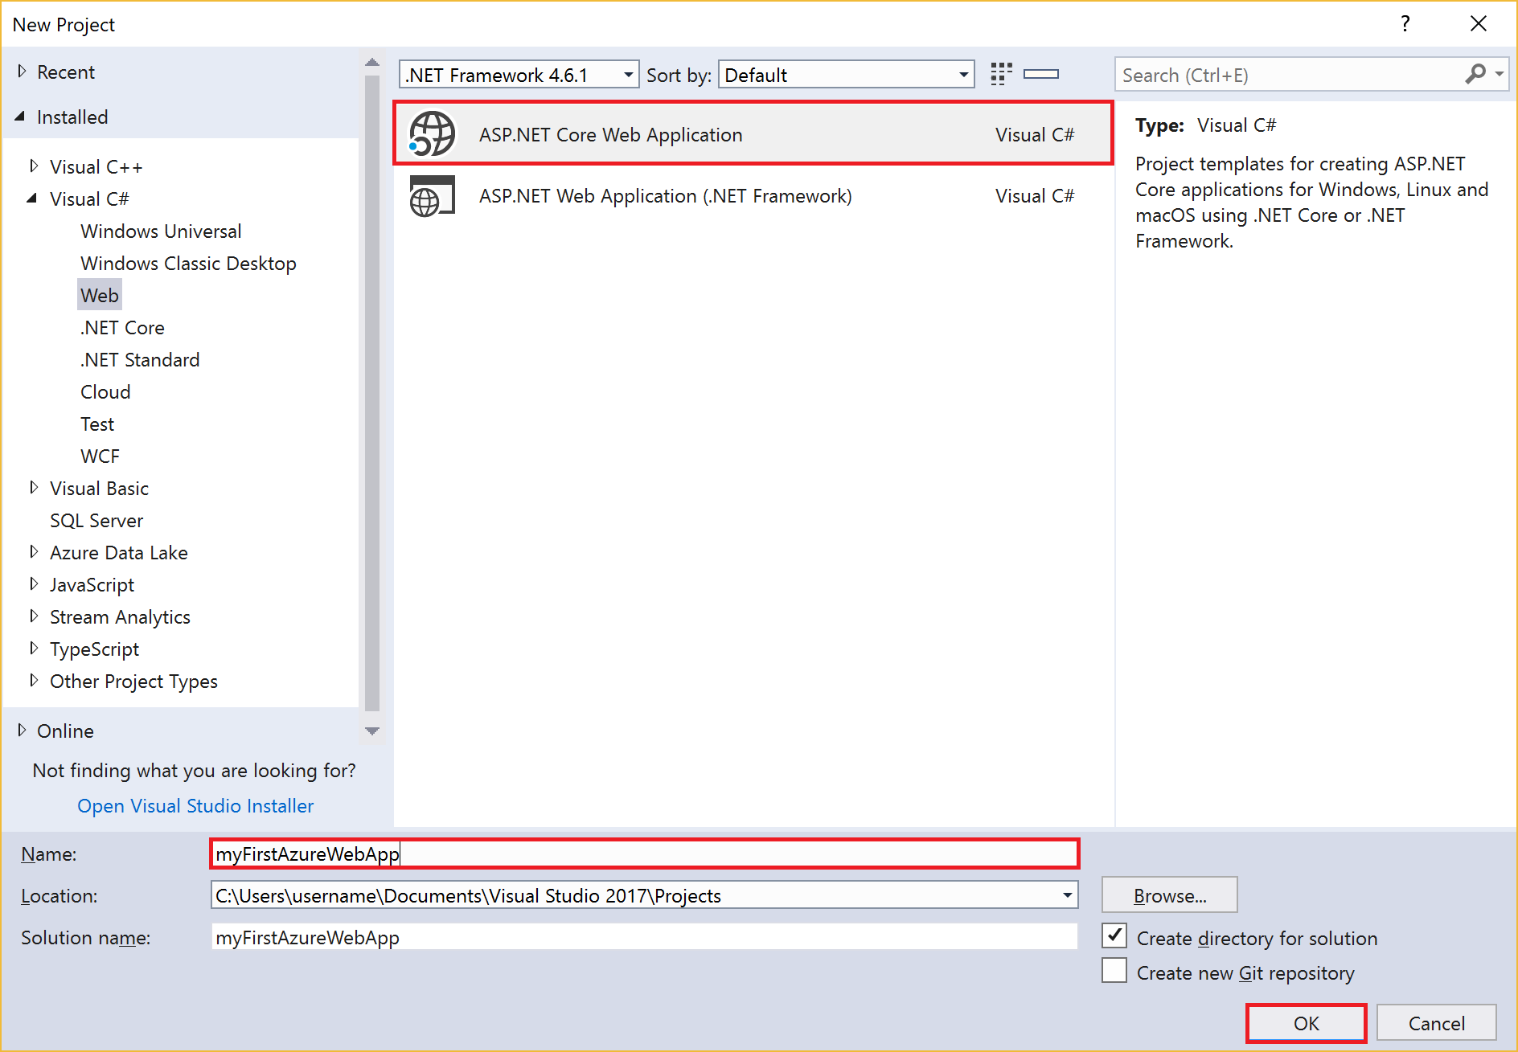

* Select the **Web Application** template.
* Select **OK**.

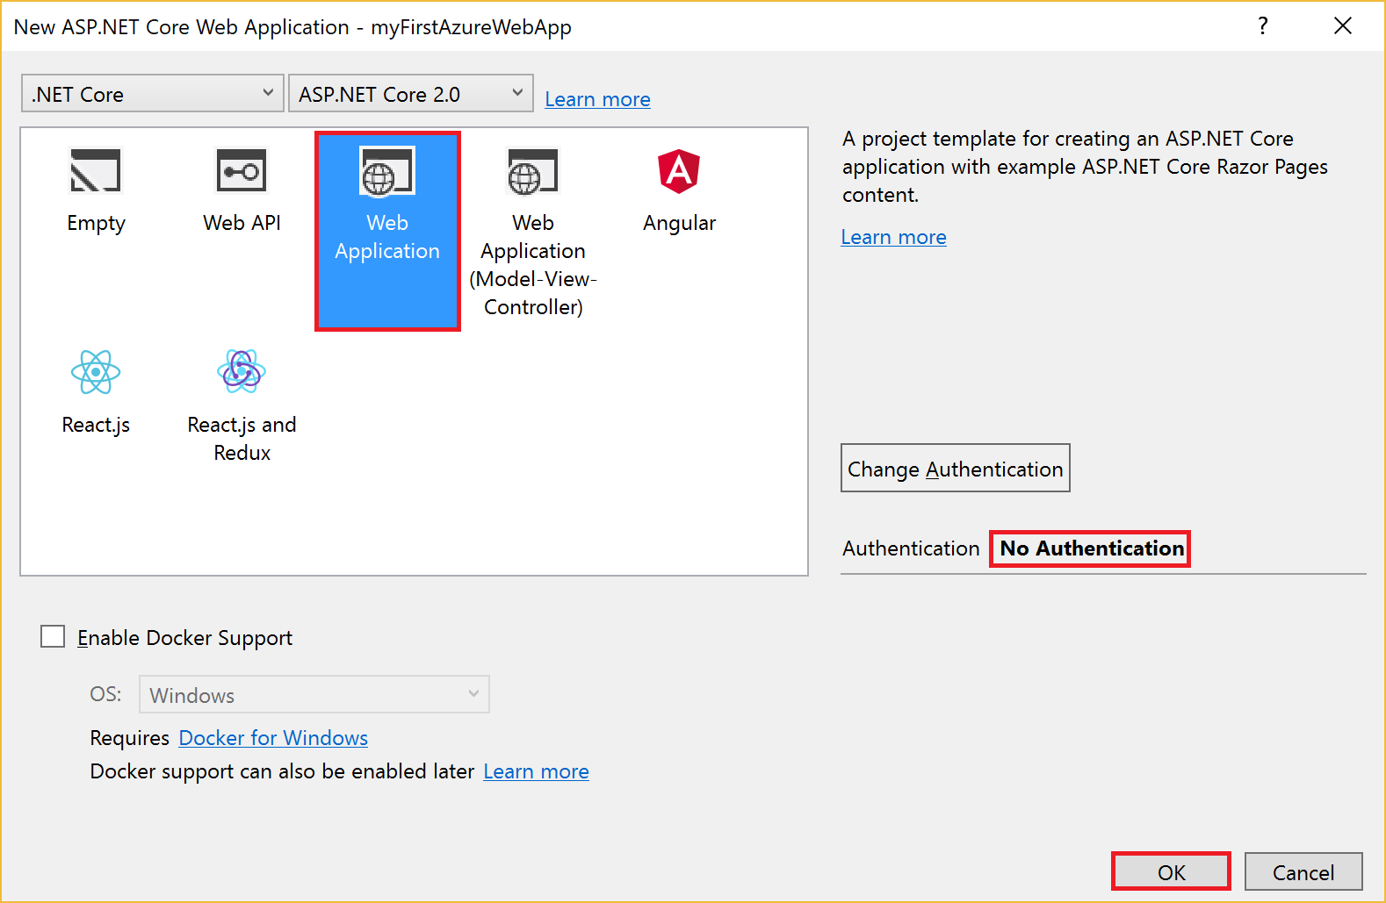

* Press **Ctrl+F5** (or go to Debug > Start without Debugging) to run the web app locally.

Publish to Azure

* In **Solution Explorer**, right-click the **myFirstAzureWebApp** project and select **Publish**.

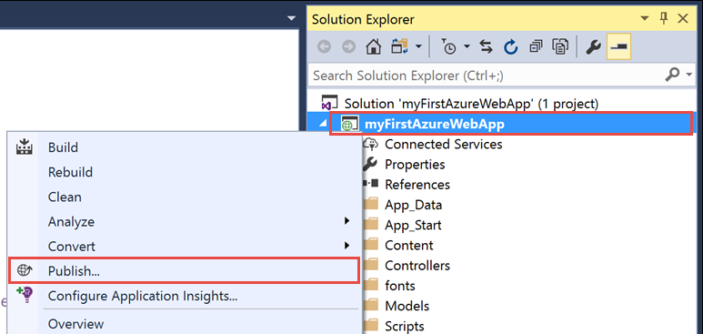

* Select **Azure App Service**, make sure **Create New** is selected, and click **Publish**.

Sign in to Azure

* If you’re already signed in, select the account containing the desired subscription from the dropdown.
* Otherwise select **Add an account**, and sign in to your Azure subscription.
  + If you don’t have an Azure subscription yet, you’ll need to [create a free Azure Subscription](https://azure.microsoft.com/free/dotnet?utm_source=VisualStudio&utm_campaign=VisualStudio&utm_medium=VSTutorials) to proceed.

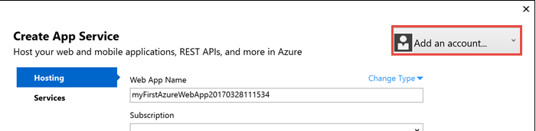

Configure your Azure Environment

* In **Web App Name**, choose a unique name for your app.  
  *The URL of the published app will be “http://<app_name>.azurewebsites.net”.*
* Next to **Resource Group**, click **New**
  + Name the resource group **myResourceGroup**
  + Click **OK**.
* Next to **App Service Plan**, select **New**
  + In the **Configure App Service Plan** dialog, choose the following values

| **Setting** | **Suggested Value** | **Description** |
| --- | --- | --- |
| App Service Plan | myAppServicePlan | Name of the App Service plan (not publicly visible). |
| Location | South Central US | The datacenter where the web app is hosted. |
| Size | Free | [Determines cost and hosting features](https://azure.microsoft.com/pricing/details/app-service/) . You'll never be charged for a Free plan. It won’t use any of your Azure credits. |

* + Click **OK**.

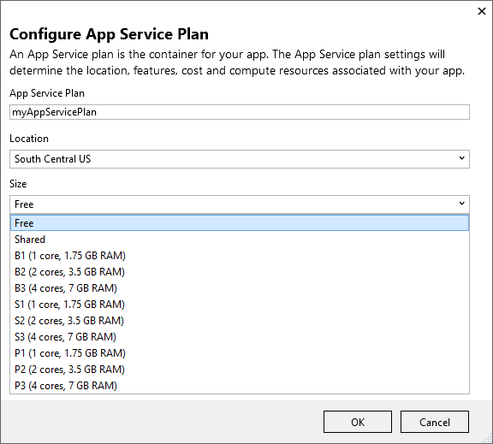

* Click **Create** to create the new Azure environment and publish the app.

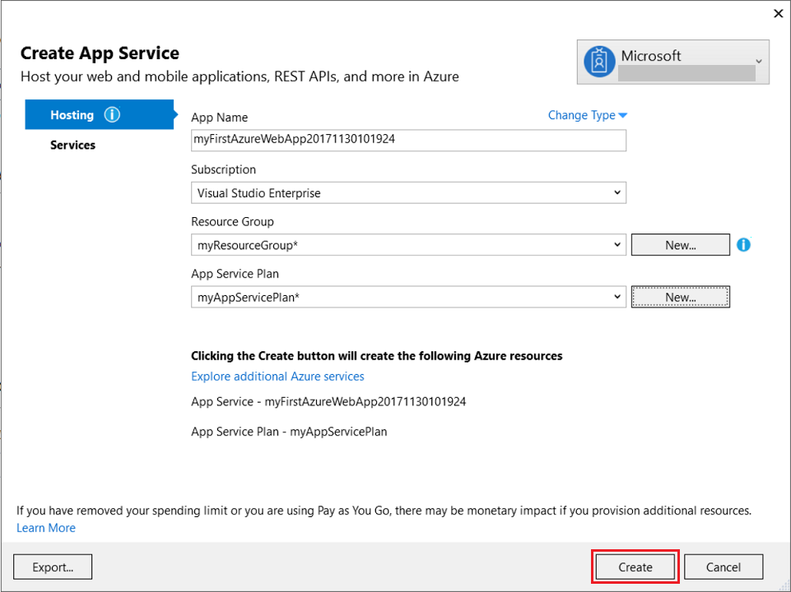

* When publish completes, Visual Studio will launch the app in your browser.

Congratulations, your ASP.NET web app is running live in Azure App Service.

Clean up resources

In the preceding steps, you created Azure resources in a resource group. If you don’t expect to need these resources in the future, you can delete them by deleting the resource group.

* Go to the [Azure portal](https://portal.azure.com/)
* From the left menu, select **Resource groups**
* Select the resource group you created (e.g. **myResourceGroup**).
* On the resource group page, make sure that the listed resources are the ones you want to delete.
* Select **Delete**
* Type the name of the resource group, and then select **Delete**.